**Microsoft Contoso Retail DataSet (34 million records) Analysis:**

**The Major Analysis are:**

* **Online Sales**
* **Sales By Channel (Online, Store, etc.)**
* **Exchange Rates (Time Variant)**
* **Sales Quota (Expected Targets)**
* **Invemtory (Products storage)**

**The following is the screenshot of the results of the Online Sales analysis:**

* **Average Customer Yearly Income By Customer Occupation and Gender (Stacked Bar Chart)**
* **Net Sales per Unit by Region Country Name (Heat Map)**
* **Net Sales Amount BY Manaufacturer (Horizontal Bar By Ranking)**
* **Average of Total Cost, UnitCost and Unit Price by Store Name (Vertical Bar for Comparison)**
* **Dynamic Calculated KPIs (Key Performance Indicators:**
* Profit
* Profit Margin
* Net Sales/Unit
* Total Cost

**BI Tool: Power BI**

**Sales Analysis**

* **By Average Total Cost, Unit Cost, Unit Price**
* **Profit by Brand Name**
* **Profit, Profit Margin, Net Sales/Unit, Total Cost (KPI)**
* **By Regional Seasons**
* **By Region (Geo Hierarchy)**
* **By Promotion Type**
* **By Stock Type**

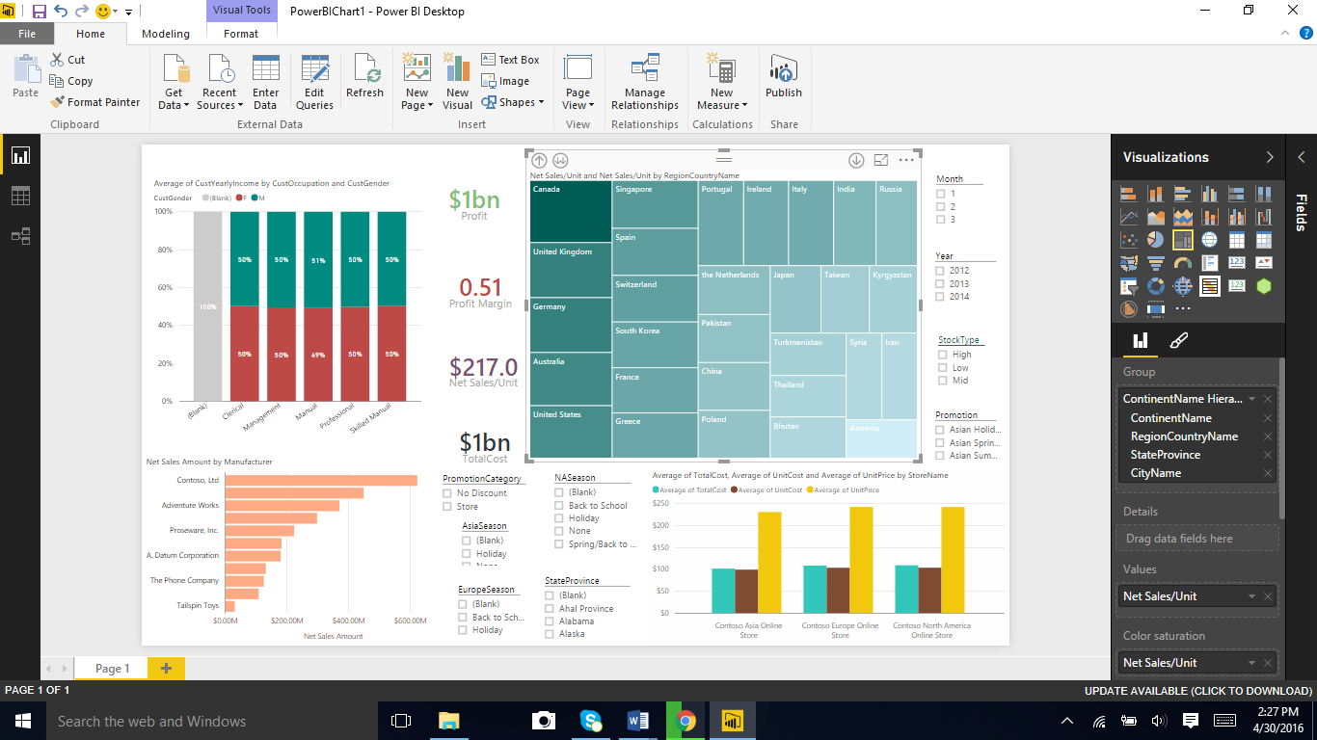

The following factors were considered as dependencies for Analysis:

* Time (Month, Year)
* Promotion Category (Whether the product was classified for discounts or stores)
* Season of the Sales (Major Continental Seasons)
* Geography hierarchy (Continent, Country, State, City)

**Tableau:**

**Inventory Analysis**

* **By Geography**
* **By Stock Count**
* **By Inventory Costs**
* **By Store Name**

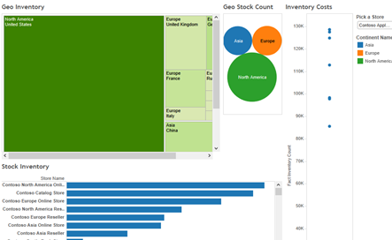

**Dundas Online BI:**

**Exchange Analysis**

* **Currency Average Rate over Complete Time**

